Subject 01 data analysis 08june2011

See far below for DF=3, 7 and accumulated DF=4,5,6 (only for KeyHolds)

DF=6
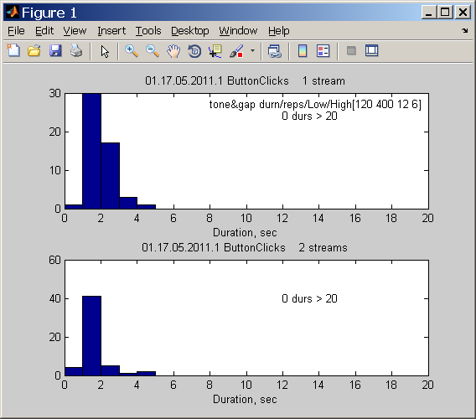
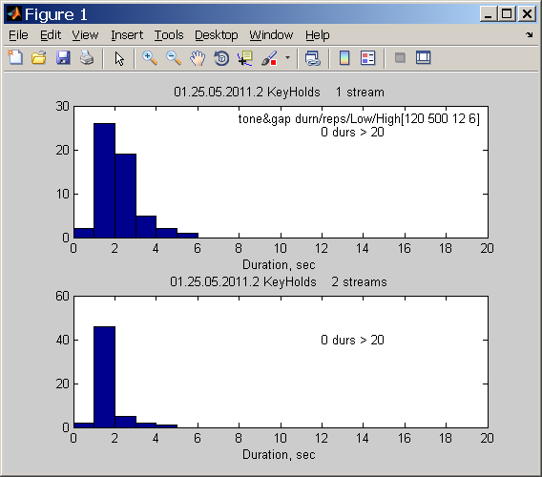

DF=5
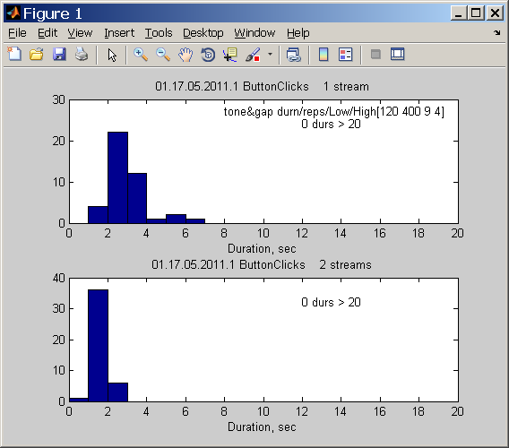
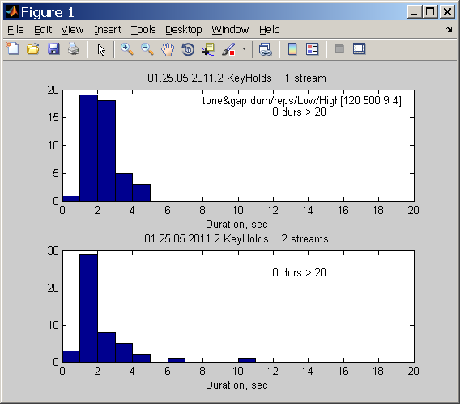

DF=4
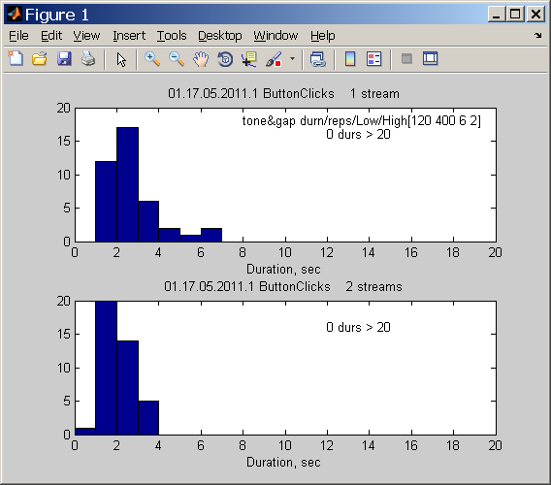
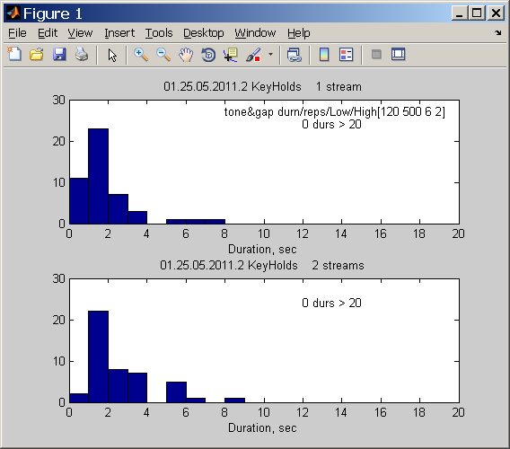

Subject 01 data analysis 08june2011

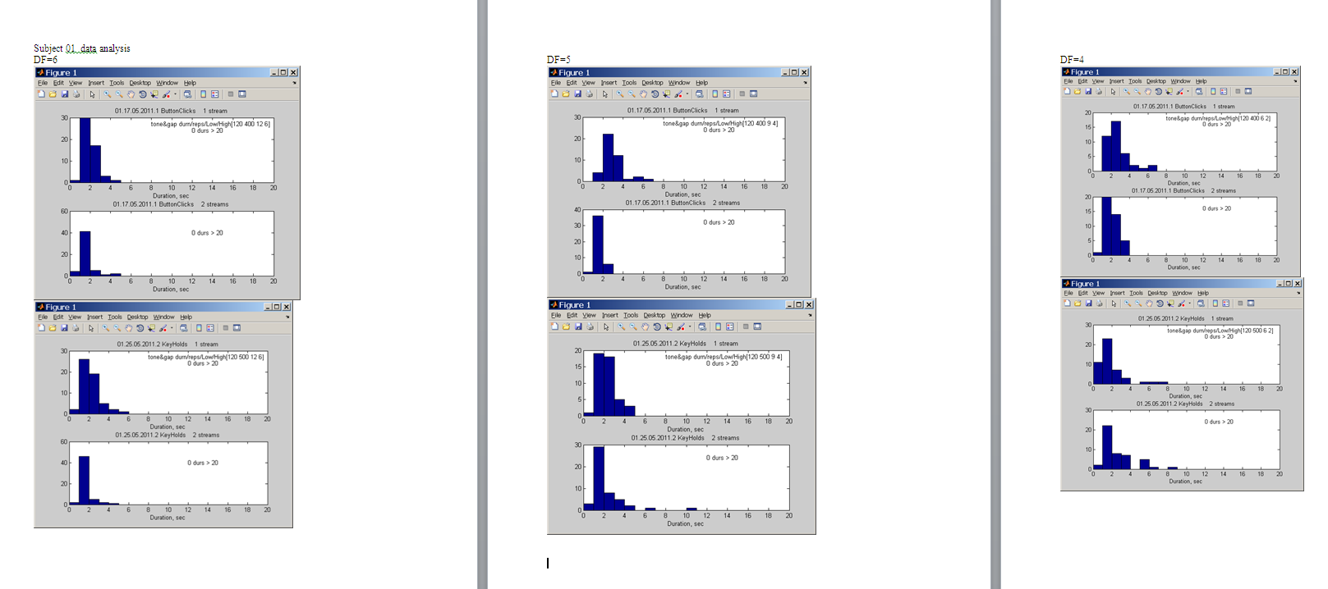

Accumulated data subj 01… key holds, 3 trials for DF=4,5,6 and 2 trials for Df=3,7.

DF=3
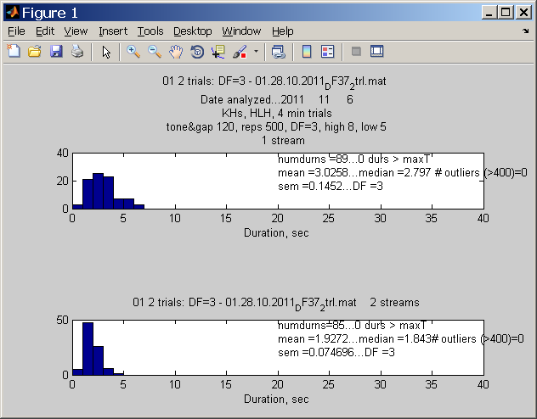
m01df3 =
89.0000 3.0258 2.7970 0.1452 3.0000 1.0000
85.0000 1.9272 1.8430 0.0747 3.0000 2.0000

DF=4 325 durns
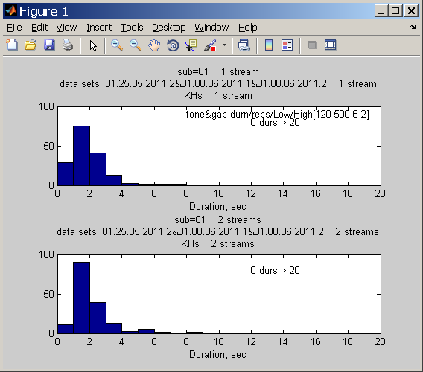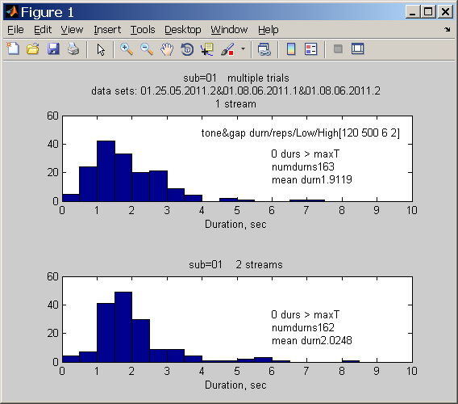

DF=5 360 durns
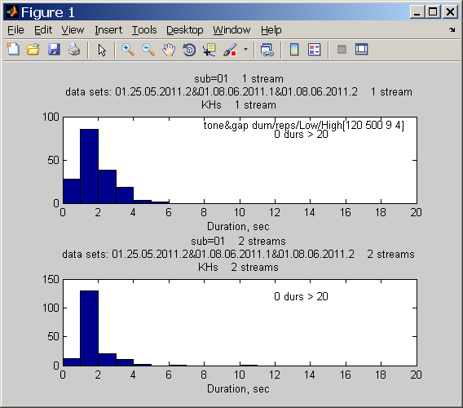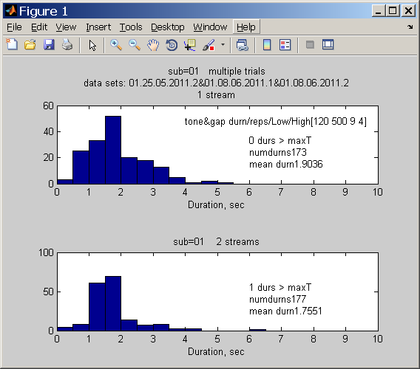

DF=6 385 durns
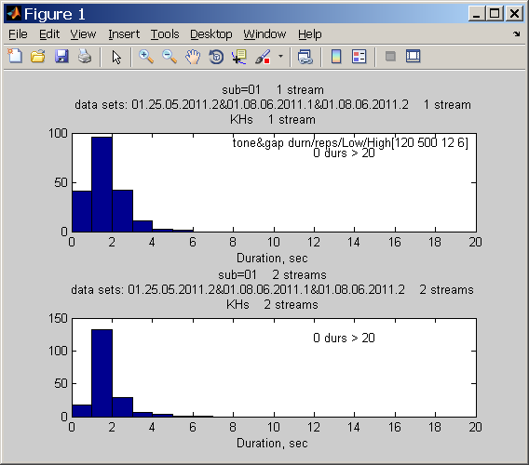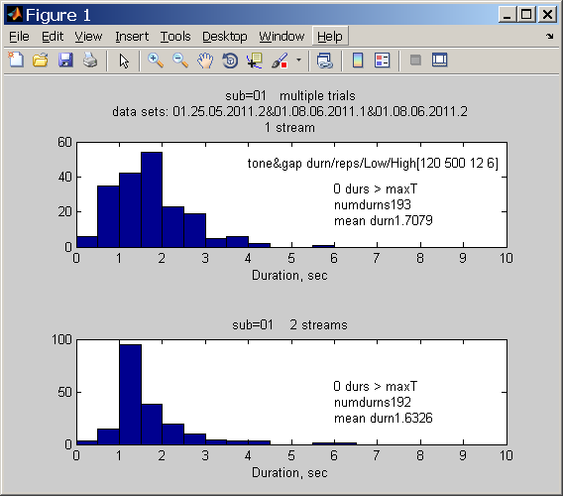

DF=7 SMTH is suspicious here… the only case for S01 with bimodel dist’n for 2-stream percept.
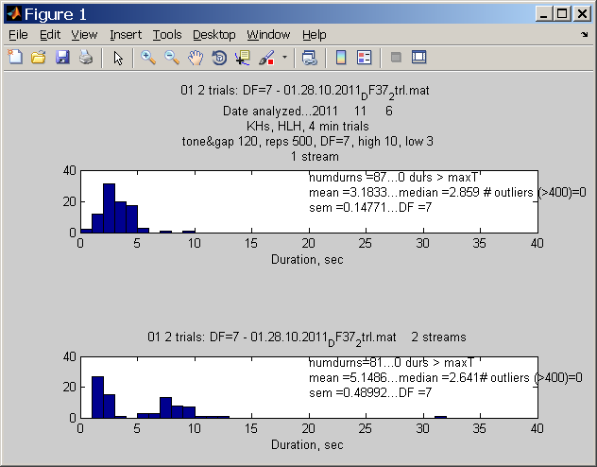
m01df7 =
87.0000 3.1833 2.8590 0.1477 7.0000 1.0000
81.0000 5.1486 2.6410 0.4899 7.0000 2.0000

